1-Encryption
# Source: Chatgpt (GPT-5-Mini) at [1/20/2026]
Encryption is the process of converting readable information (called plaintext) into an unreadable form (called ciphertext) so that only authorized people or systems can access it.

In simple terms
# Source: Chatgpt (GPT-5-Mini) at [1/20/2026]
It’s like locking your data with a secret code.
Only someone with the right key can unlock (decrypt) it and read the original information.

Why encryption is used
# Source: Chatgpt (GPT-5-Mini) at [1/20/2026]
- 🔒 Protect privacy (messages, emails, photos)
- 💳 Secure sensitive data (passwords, credit card numbers)
- 🌐 Keep online communication safe (HTTPS, messaging apps)
- 🏢 Protect stored data (phones, laptops, databases)

How it works (basic idea)
# Source: Chatgpt (GPT-5-Mini) at [1/20/2026]
- You start with plain text:
Hello
- Encryption uses an algorithm and a key to scramble it:
X9$@!k
- The receiver uses the correct key to decrypt it back to:
Hello

Types of encryptions
# Source: Chatgpt (GPT-5-Mini) at [1/20/2026]
- Symmetric encryption
  - Same key for encrypting and decrypting
  - Fast, but key must be kept secret
  - Example: AES
- Asymmetric encryption
  - Uses two keys: a public key (to encrypt) and a private key (to decrypt)
  - More secure for sharing data
  - Example: RSA

Everyday examples
# Source: Chatgpt (GPT-5-Mini) at [1/20/2026]
- WhatsApp “end-to-end encryption”
- Locking your phone with a passcode
- Secure websites (https://)

2-Decryption
# Source: Chatgpt (GPT-5-Mini) at [1/20/2026]
Decryption is the process of converting encrypted data (ciphertext) back into its original, readable form (plaintext).

In simple terms
# Source: Chatgpt (GPT-5-Mini) at [1/20/2026]
If encryption is locking information, decryption is unlocking it using the correct key.

How decryption works
# Source: Chatgpt (GPT-5-Mini) at [1/20/2026]
- You receive encrypted data:
X9$@!k
- You use a decryption key (or private key)
- The data is restored to readable form:
Hello

Why decryption is important
# Source: Chatgpt (GPT-5-Mini) at [1/20/2026]
- 🔓 Allows authorized users to read protected information
- 🔐 Ensures secure communication
- 🛡️ Prevents unauthorized access to sensitive data

Types of decryptions
# Source: Chatgpt (GPT-5-Mini) at [1/20/2026]
- Symmetric decryption
  - Uses the same key that was used for encryption
  - Example: AES
- Asymmetric decryption
  - Uses a private key to decrypt data encrypted with a public key
  - Example: RSA

Everyday examples
# Source: Chatgpt (GPT-5-Mini) at [1/20/2026]
- Opening a password-protected file
- Reading an encrypted message in a chat app
- Unlocking a secure website connection (HTTPS)

Encryption vs Decryption (quick comparison)
# Source: Chatgpt (GPT-5-Mini) at [1/20/2026]
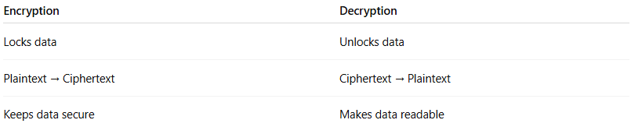
Encryption | Decryption
Locks data | Unlocks data
Plaintext → Ciphertext | Ciphertext → Plaintext
Keeps data secure | Makes data readable

